**Uniformed Protective Services Kit list**

**MANDATORY TOPS**

Please purchase tops from the following link <https://lisssport.co.uk/WNC>

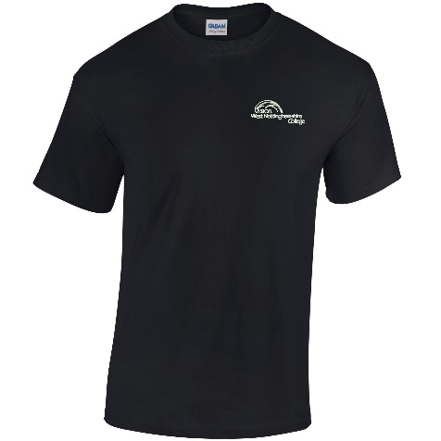

**TROUSERS**

It is essential that all learners purchase the following trousers from our supplier.

[Black PCS Delta Trousers | 28 to 48 Inches | Highlander Forces (cadetdirect.com)](https://www.cadetdirect.com/black-pcs-type-combat-trouser)

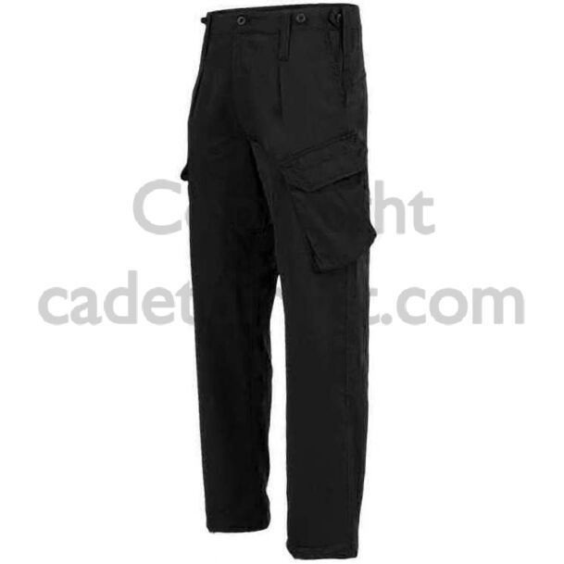

**BOOTS**

Must be black with laces (no zips). Can be purchased from anywhere you choose. Example below.

