**BTEC Level 2 Sport**

**New applicant activity**

**Why are BTECs so successful?**

BTECs embody a fundamentally learner-centred approach to the curriculum, with a flexible, unit-based structure. In these new BTEC Level 2 Technicals, the focus is on the development of technical, practical and transferable work-related skills, and sector-specific knowledge. The development of these skills is key for learners to progress to work or to an Apprenticeship.

When creating the BTEC Level 2 Technicals, we worked with employers to ensure that the qualifications meet their needs. Employers are looking for recruits with the appropriate technical knowledge, and technical and transferable skills essential for employment.

**Who is the qualification for?**

This qualification is for learners who want to start a career in sport and physical activity. It is designed for post-16 learners and can be taken as part of a wider study programme. It is an ideal qualification for learners intending to progress directly to employment in sport and activity leadership, or to an apprenticeship.

**What does the qualification cover?**

This qualification has been developed in consultation with employers and the professional body in the sport sector to ensure learners develop the skills and behaviours that will give them the best opportunity to be successful when applying for work.

Most of the content of the qualification is mandatory and relates directly to the skills, knowledge and behaviours expected by employers in the leisure sector of a sport and activity leader. The areas covered include:

• working in sport and activity leadership

• leading sport and activity safely and effectively

• leading sport and physical activity

• coaching sport

• developing skills for sport and activity leadership

• delivering a sports event.

**What could this qualification lead to?**

Achieving this qualification will give learners an advantage when applying for sport and activity leadership roles. It will also support progression to apprenticeships in sport and leisure.

When studied as part of a full study programme, typically alongside maths or English, this qualification also gives learners a sound basis to progress further in the sport sector to a Level 3

Tech Level qualification such as a Pearson BTEC Level 3 National Diploma in Fitness Services.

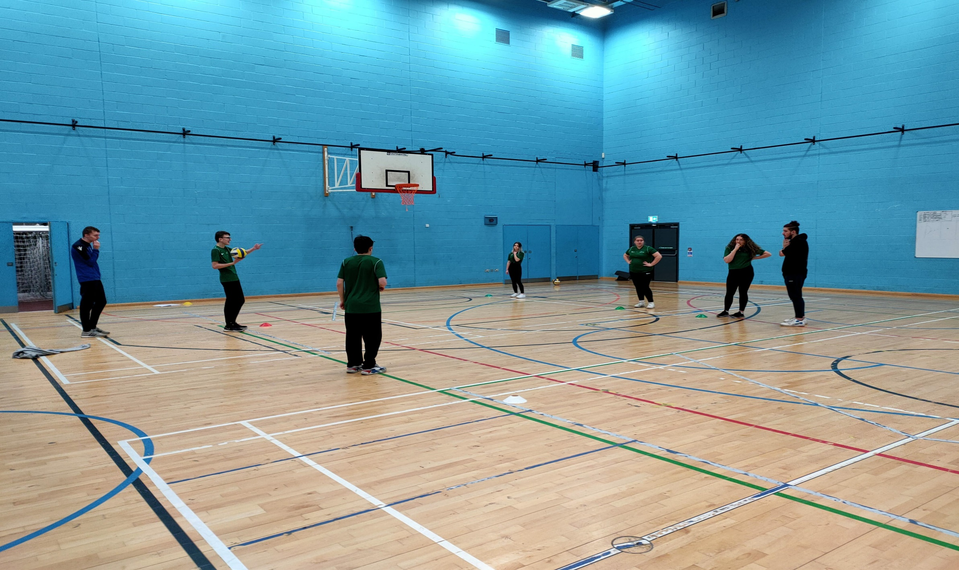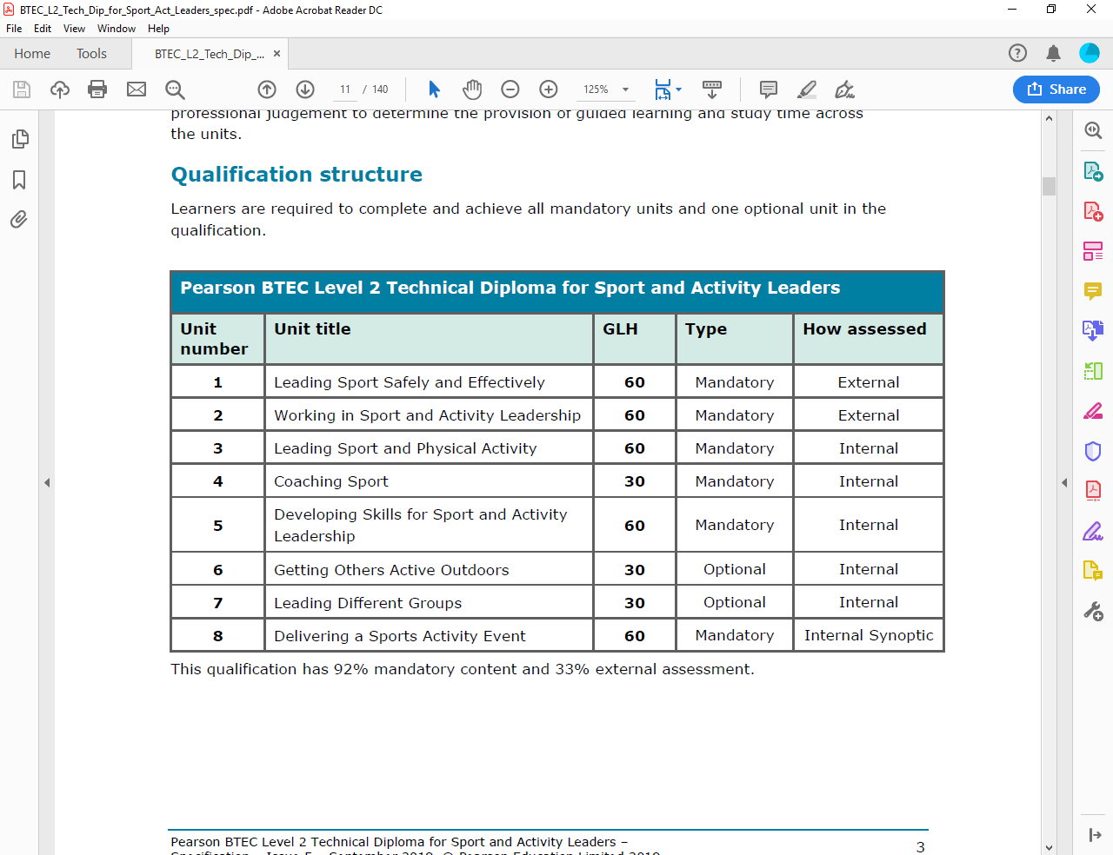

Example of student coaching.

**Applicant activity**

**Please send your completed activity to Jon Keresztury by email:** [**Jonathan.Keresztury@wnc.ac.uk**](mailto:Jonathan.Keresztury@wnc.ac.uk)

Please provide some feedback with the questions below.

**Why would you like to come to West Nottinghamshire College and study our level 2 sport qualification?**

**What makes a good sports coach?**

**Please watch the short clip below to help answer the question relating to what makes a good coach.**



[**What makes a good sports coach?**](https://youtu.be/_CB3OichLBU)

**Can you explain what you think makes a good sports coach?**