OneDrive
OneDrive is the way to store your data whilst attending College. Your work can be accessed either in the cloud, on a college computer and on phones and tablets. You can download the app to your personal computer/Laptop, or get it from the Apple or Google Play Store for your mobile devices. You can access your data from almost everywhere.
When you have logged onto a college computer you should see this icon (a blue cloud) in the items near the clock in the bottom right-hand side of your screen.
This means that OneDrive has connected and is syncing your files. It is not downloading them, but it is making them visible on this computer. Depending how much data you have stored it may take a few minutes to complete the sync.
If there is no cloud icon in the area near the clock or you see this icon (a blue cloud with a diagonal line through it) you can run and sign into OneDrive by selecting it from the Start Menu.
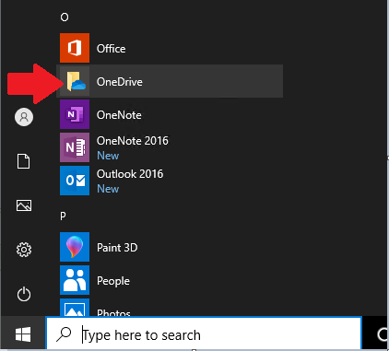
This will ask you to sign into OneDrive.
Put in your usual MS Teams/Office 365 log in (for most staff this is currently id number@students.wnc.ac.uk) and select Sign in. You will then be prompted for your password (your regular network password)
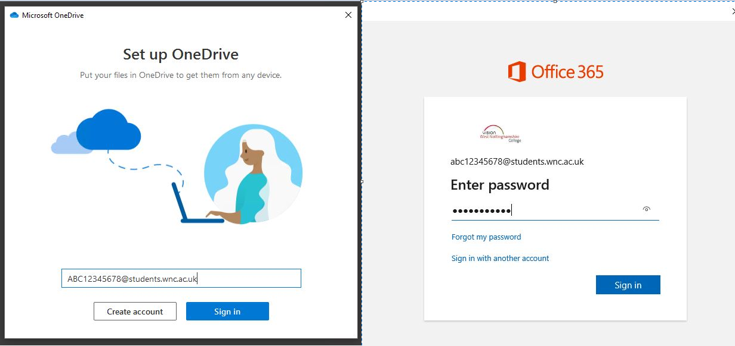
You will see a few screens informing you about OneDrive.
When OneDrive is setup you will see a new folder in Windows Explorer.
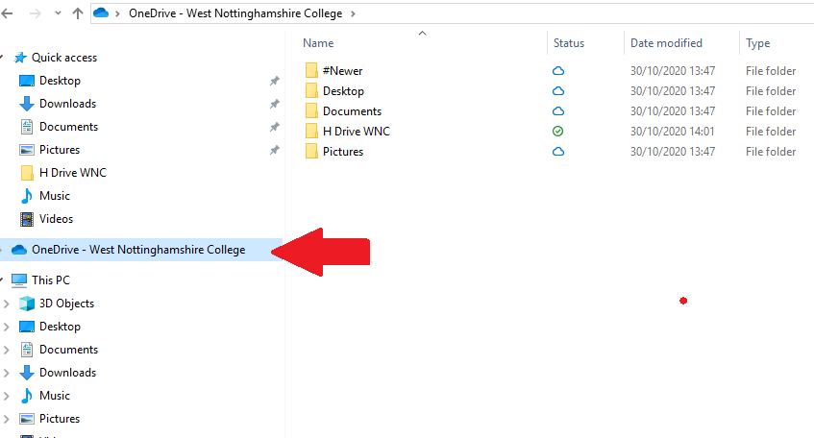
Inside here you will see all your file and folder titles that are stored in Microsoft 365 (was Office 365). If you open a file it will first download to your local computer and let you work on it. All changes that you make will be synced to your online OneDrive
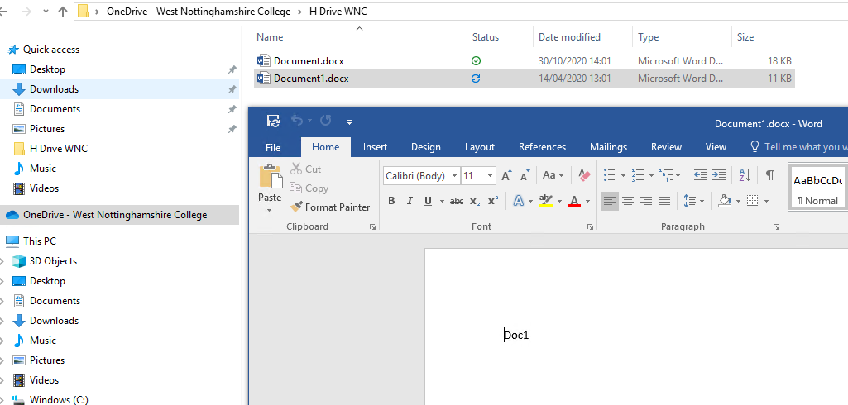
If you change computers, this process will be repeated.
Always access and save your folders and files to OneDrive:

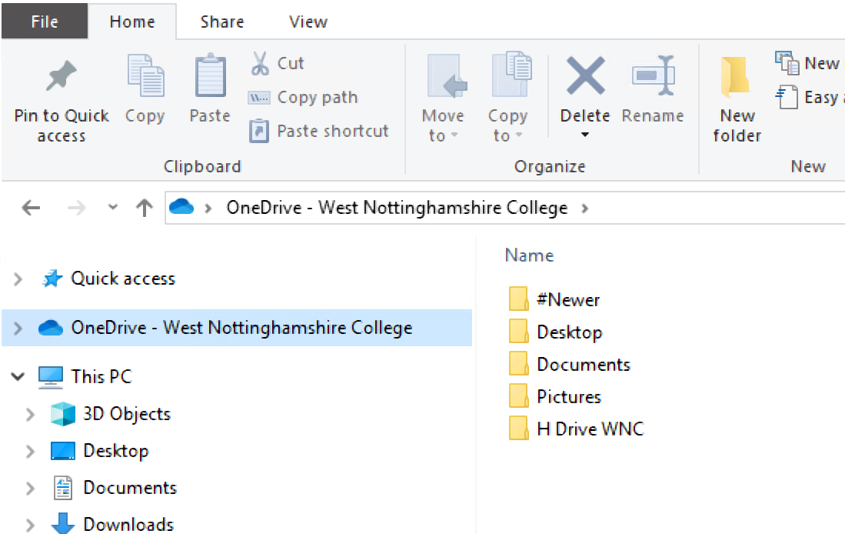
Before you leave college, it is your responsibility to remove/download your work as once you have left your account will be deleted and you will no longer have access to any of the content.

