eduroam - wireless access for staff
The eduroam wireless network service is available for West Nottinghamshire College staff when using personal devices^{i}.
- How to connect
- Visitors
- What is eduroam?
- Availability
- Code of Practice

^{i}College owned mobile devices and laptops should not use eduroam. If you are having issues with access to the corporate wifi on a college device please seek help from the IT Helpdesk

How do I connect?

iOS
- Go to Wi-Fi settings on your device
- Select the Wi-Fi network 'eduroam'
- When prompted, enter your Office365 username.
e.g. abc123456@westnotts.ac.uk
- Enter your college password
- Trust the certificate if prompted.
You should only need to authenticate once using your college username and password and after that you'll automatically connect to eduroam every time you come on site. You will need to forget the network and repeat these steps if you change your college password.

Android
- Before coming on site download the app called ‘Geteduroam’. 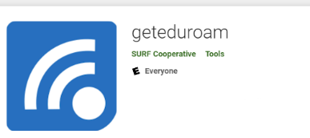
- Open the app and search for the college.

- Once West Nottinghamshire College is chosen click ‘Next’.
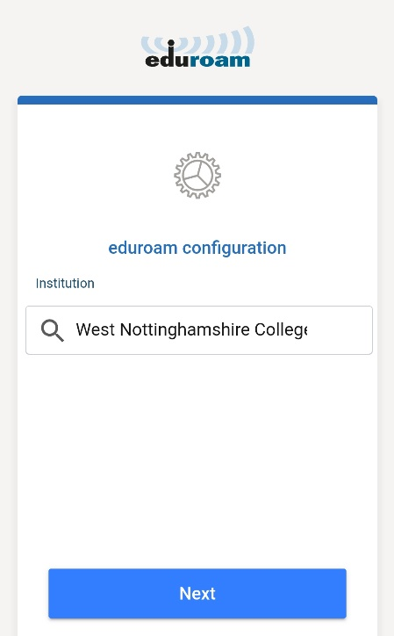

- The app will ask for your college details.
Enter your College username followed by @westnotts.ac.uk
e.g. abc123456@westnotts.ac.uk
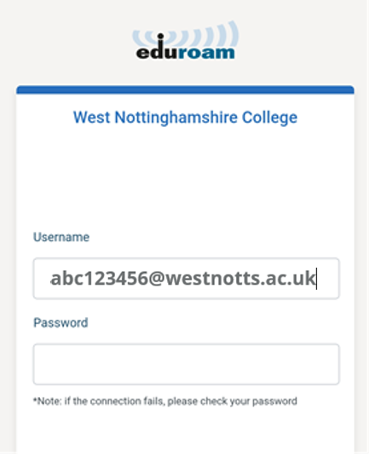
- Enter your college password then click ‘Connect to Network’
- Once this is complete the app should automatically connect you to eduroam once the network is in range.

You should only need to authenticate once using your college username and password and after that you'll automatically connect to eduroam every time you come on site. You will need to repeat steps 2 to 6 if you change your college password. If the app does not connect once you are on site please seek help from the IT Helpdesk in the LRC.

What is the eduroam wireless network?
The eduroam service also allows users who are working away from their home institution to use local wifi facilities if their home institution is also part of the eduroam network.
An organisation can take part in the eduroam service through being a ‘Home’ institution, a ‘Visited’ institution, or both:
- a ‘Home’ institution provides authentication for its users when they wish to access internet facilities at a participating ‘Visited’ organisation
- a ‘Visited’ institution permits members of other organisations to use its internet facilities whilst on site using their 'Home' institution credentials
West Nottinghamshire College participates as both a ‘Home’ and a ‘Visited’ institution.

Visitors to the college from another participating institution
To connect to the eduroam service whilst at West Nottinghamshire College, please ensure that your device has been set up correctly before your visit.
Your local IT Support service should be able to assist with the required configuration. You will need to enter your home username and password in order to connect to the eduroam service if these credentials are not already cached on your device. The user credentials supplied by your device must identify your home institution e.g. xyz@abc.ac.uk would identify user xyz from college/university abc.
If you encounter problems, please contact your home institution for assistance.

Availability
For the latest information about where eduroam is available in the UK, visit JANET roaming locations.
For information about where eduroam is available globally, visit the eduroam website.

Code of Practice
Whilst at a participating site, you are bound by guidelines and the acceptable use policy of the site you are visiting. Failure to adhere could result in disciplinary procedures.

eduroam(UK) policy
The eduroam(UK) policy can be found on the JANET website.

