**Uniformed Protective Services Kit list**

**Learners need to order by Monday 10 July 2023 for delivery first full week in September 2023**

**MANDATORY TOPS**

Please purchase tops from the following link <https://lisssport.co.uk/WNC>

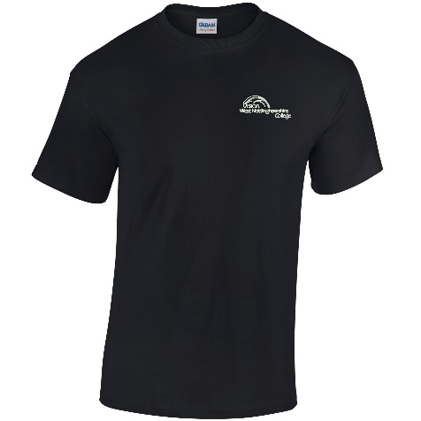

**TROUSERS**

It is essential that all learners purchase the following combat trousers from our supplier.

Cadet Forces PCS MTP Combat Trouser

<https://www.cadetdirect.com/cadet-forces-pcs-mtp-combat-trouser>

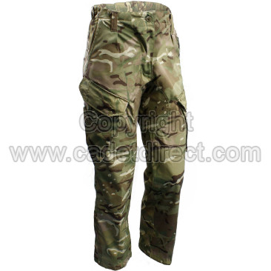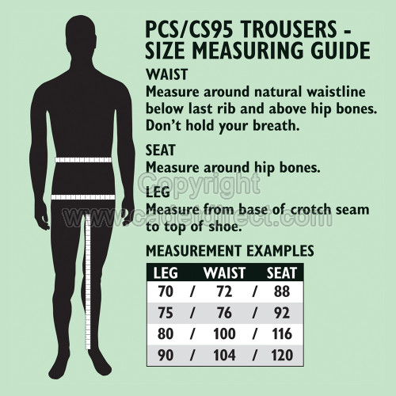

**BOOTS**

Must be black with laces (no zips). Can be purchased from anywhere you choose. Example below.

